Edwards Family History

Edwards is an English and Welsh name of Saxon origin, derived from two words that mean “happy or blessed” and “keeper or protector.” An “s” was added to the original name of Edward to indicate “son of Edward.”

Various forms of the surname Edwards appeared in English records as early as 1379. One of the first Edwards families emigrated from Cardiff, Wales, to Virginia in the early 1600’s. By the first U.S. Census in 1790 over 3,000 Edwards members were living in America, with the largest numbers found in Virginia and North Carolina (from The Edwards Family, Heritage Press).

**Thomas Alvin Edwards (1735 -?)**

The earliest known member of our Edwards branch is probably Thomas A. Edwards, who was born in Westmoreland County in northern Virginia. In 1760 he married **Elizabeth (Betsy) Willis Martin** (1739 -?), widow of John Shadrack, in Fauquier County, VA, just west of Washington, DC. They moved to the small town of Mill Spring, North Carolina, in Rutherford County. They had nine children between 1762 and 1783, including **William**, Martin (who became a preacher and moved to Georgia), and Andrew Striplin, who moved to Tennessee. One source says that Thomas A. Edwards served in both the French and Indian War and the Revolutionary War, and held the rank of Captain.

Children of Thomas and Betsy Edwards:

Martin (1782)  
Nancy (1763)  
**William (1767)**  
Elizabeth (1770)  
Charles (1772)  
Thomas (1774)  
John (1777)  
S. P. (1777)  
Ellis (1779)  
Andrew Striplin (1783)

**William Edwards (1767 - 1839)**

**William Edwards** was the third child born to Thomas and Elizabeth Edwards, probably in Virginia. Later he lived in Rutherford County in western North Carolina. He married **Elizabeth (Ailsie) Justice** (1773-1852), who was born in Virginia, probably the daughter of **Thomas** and **Mary Dyer Justice**. Thomas Justice was born around 1737 in Halifax County, Virginia, moved to Rutherford County, North Carolina, and served in the Revolutionary War. He was descended from William Justice, who immigrated to Charles City County, Virginia, from London about 1650. Both Thomas Edwards and Thomas Justice are listed in the1790 Census in Rutherford County. William and Ailsie Edwards were the parents of at least 6 children:

* Elizabeth Brown (1791-1863)
* **Thomas Striplin (1796-1875)**
* Amos (1808-1862)
* Martin (1809-1862)
* James L. (1814-1848)
* William Holiday

Around 1803 the family moved across the Appalachian Mountains to Overton County, in northern Tennessee, where they stayed for about 20 years. The exact location is unknown. Overton County was much larger at that time than it is today. Later they moved north into Illinois, and lived in several locations, finally settling in Pittsfield in Pike County, where William and Ailsie Edwards died and are buried.

**Thomas Striplin Edwards, Sr. (1796 – 1875)**

**Thomas S. (Tom) Edwards** was born in Rutherford County, North Carolina, and moved with the family to Tennessee as a young boy. There he grew to manhood and married **Elizabeth Atterberry Hudspeth**, a widow with 5 children, who was six years his senior. Elizabeth Atterberry was born in 1790 in South Carolina, to Nathan Atterberry and Priscilla Mayfield. She moved to Overton County, Tennessee, and in 1808 married William Giles Hudspeth from Surry County, North Carolina. Their first four children (Sarah, James, Lydia and Nancy) were born in Overton County. Their last child, George Hudspeth, was born in 1815 in Madison County, Alabama, some 200 miles to the southwest. Just 11 months later her husband died. Elizabeth Hudspeth then took her five children and moved back to Overton County, Tennessee, where she met and married Thomas S. Edwards in about 1819.

The first child of Thomas S. and Elizabeth Edwards was **Francis Marion Edwards**, born in 1820 in Overton County. A second son, William, was born a year later. By 1822 the entire family, including Thomas’ parents, had moved to Mt. Vernon, Illinois, where a third son, Thomas Striplin Edwards, Jr., was born. A short time later they moved to Menard County, which was then part of Sangamon County. They were among the early settlers of Clary’s Grove, a small community northwest of Springfield. Their last child, Ellen Shephard Edwards, was born there in 1825.

Clary’s Grove was only a few miles from the village of New Salem, home of Abraham Lincoln from 1831 to 1837. Lincoln operated a store and first ran for public office while he lived in New Salem. Many Lincoln biographies tell the story of his wrestling match with Jack Armstrong, the leader of the “Clary’s Grove Gang.” Armstrong was a cousin of John G. Shastid, husband of Tom Edwards’ sister Elizabeth. While there is no evidence that any of the Edwards males were a part of this gang, a newspaper column written in 1860 by John Hay quotes Tom Edwards’ account of the wrestling match (see except from Providence Journal of 9/19/1860). In 1832 Lincoln was elected coronal of a local militia that was called out to fight against Chief Black Hawk in what was called Black Hawk’s War. Thomas Edwards served as a captain under Lincoln in this militia, but the troops saw no actual fighting. Abe Lincoln and Thomas Edwards apparently remained friends. In 1861, between Lincoln’s election to the presidency and his inauguration, Thomas wrote him a letter offering his political advice (see letter to A. Lincoln). In addition, John Hay’s column credits Tom Edwards with convincing Lincoln to intervene in a murder trial involving Jack Armstrong’s son.

About 1835 most of the family moved to Pike County, Illinois, just south of Quincy. **George T. Edwards**, son of Elizabeth Brown Edwards, became a well-known businessman and hotel owner in Pittsfield (see biography of G. T. Edwards). He also served a term as sheriff of Pike County, and at the age of 48 organized a company of soldiers from the county that fought in the Civil War. He was married three times.

While the family was living in Tennessee, Elizabeth Edwards married John Greene Shastid, a cousin of the Greene family who also moved to Menard County and became prominent early settlers. His ancestors on his mother’s side included the Justice family, who moved from Rutherford Co., NC, to Tennessee and then Illinois, and were Ailsie Justice’s ancestors, as well. Elizabeth and John Shastid also followed the family to Menard and later Pike County. They had 8 children. John Shastid died in 1874 and Elizabeth died in 1863.

Martin Edwards and his wife Emily also remained in Pike County. He died in 1862.

**The Mormon Years**

Late in the year 1837 a group of followers of the Church of Jesus Christ of Latter-day Saints (Mormons) were being forced to leave Missouri. They located on the west bank of the Mississippi River and built log cabins in which to pass the winter. However, conditions were hard and food was scarce. In February 1838 the group crossed the river and went as far as Pittsfield, Illinois, where “Thomas Edwards made them offers of land on favorable terms, and the brethren concluded to settle. Being joined by others, a branch of the Church was formed.” *(Andrew Jensen, LDS Biographical Encyclopedia*). This may be where the Edwards family first came in contact with the followers of Joseph Smith.

James Allred and his family were a part of this group. They moved from Bedford County, Tennessee, to southern Missouri in the early 1830s, where they joined the Mormon movement. In July 1839 Allred’s daughter Eliza Maria married George T. Edwards, brother of Tom Edwards, in Pittsfield (see biography of G.T.Edwards). The Allred family moved on to Nauvoo. The area around Nauvoo was wet and marshy, and many of the new settlers grew sick and died, including James’ son Martin and his wife. James and his wife Elizabeth raised their 8 children along with their own. One of them was Eliza Elvira Allred, who married William H. Edwards, son of Thomas Edwards, Sr. Their only child, Jerusha Smith Edwards, married another Allred grandchild, Sidney Little Allred. James Allred was a personal bodyguard for Joseph Smith, and became an important leader in the LDS Church when Brigham Young led them to Utah.

Some time before 1840 the Thomas S. Edwards Sr. family relocated from Pike County to Nauvoo, IL, in Hancock County, on the Mississippi River. Joseph Smith, the founder of the LDS (Mormon) Church, had established the community in 1839. Thomas S. Edwards and his family joined the movement. Thomas S. Edwards is listed as being appointed an elder of the Church on October 5, 1839, but declined. According to the records of the Reorganized LDS Church (now called the Community of Christ):

*“Thomas S. Edwards joined the Church of Jesus Christ of Latter-day Saints and offered his home as an asylum for the persecuted Saints. He received his patriarchal blessing on 22 November 1842 at Nauvoo, Hancock, Illinois, from Hyrum Smith. He materially supported the Church and served a mission before the martyrdom of the prophet Joseph Smith. He was baptized a member of the Reorganized Church of Jesus Christ of Latter Day Saints on 25 April 1871. His funeral services were conducted by* *Joseph Smith III.”*

Apparently all four of his children, Thomas S. Jr., Francis M., William H., and Ellen S. Edwards joined the LDS Church, as well. In one reference both Thomas Sr. and Thomas Jr. as well as William H. and Ellen Edwards are listed as living in the Mormon settlement in northern Missouri, in the late 1830’s, but no other evidence supports this. In another reference about the early history of the Mormon Church, a “Brother” Thomas Edwards is identified as being with Bishop George Miller on a mission to Kentucky when they received news that Joseph Smith and his brother Hyrum had been killed by a mob near Nauvoo in 1844. Records also show that on February 23, 1844, Thomas S. Edwards was part of a group of 23 men who volunteered to explore Oregon and California for the LDS Church. This was in preparation for carrying out Joseph Smith’s dream of finding a haven for his followers in the less settled western states. The trip was never made, though.

It is not clear whether the above anecdotes refer to Thomas S. Edwards Senior or Junior. However, the following November 1, 1843, newspaper account clearly refers to Thomas Edwards, Junior, and another mission trip he made with James Butler through Illinois and Kentucky. Thomas Edwards, Jr. was only 19 years old at the time.

*“……compliance with council, we proceed to give you a short account of our recent mission. We left Nauvoo on the 15th of January, pursued our way to Burton, Adams county, where we preached three times and baptized one; from thence to Greene County , preached several times and baptized one; thence to Highland, Madison county; preached several times and baptized three, where by the help of brother Cooper, a high priest, we organized a branch, consisting of seven members; ordained one priest. We pursued our journey from there to Mercer county, Kentucky, where we preached six weeks, and raised up and organized a branch of seven members, ordained one elder, and one priest. From there we proceeded to Lexington, Ky., where earnest solicitations were made for preaching; doors and chapels were opened in every direction, and the cause to truth prospered wherever we had the privilege of raising our voices. It was the earnest request of the citizens of Lexington and its vicinity, that an elder should be sent to them, and offered to open their doors at all times to hear the gospel.*

Yours, in the bonds of the new and everlasting covenant, THOMAS S. EDWARDS, jr., JAMES BUTLER.”

Later, Lyman Richards (*Reminiscences of Latter-day Saints*) described his mission trip near Alton, Illinois, and wrote that “Elders James Butler and Thomas Edwards had done a good work through that country and I was much pleased to meet with them while there.” Francis M. Edwards is also listed as having performed missionary service to Jackson Co., Tennessee and Kentucky in 1843, and to Indiana in 1844. William H. Edwards accompanied his brother in 1843. Following is a news account Francis M. gave of their trip.

*“Sir: I devote a few moments of time, to give a short sketch of the prosperity of the mission appointed me, to Tennessee, at the last April Conference. I left Nauvoo on the 11th of April and went to Greene County, Illinois, where I preached a few times and baptized two. From thence I went to Lebanon, St. Clair Co. where I fell in company with W.H. Edwards, who accompanied me to Tennessee. We baptized eight near Lebanon, and organized them into a branch, known by the name of the Lebanon Branch. From Lebanon we continued our way, preaching every opportunity, and baptized two at the Elk-horn prairie, Williamson Co., crossed into Kentucky, May 18th; continued preaching in Warren, Barren, Hart, and Monroe Counties, Ky., and Jackson and Overton Counties, Tenn., for about five months; baptized ten in Hart Co., all of whom will remove to Nauvoo this winter or next spring. The enquiries for the doctrines of the Church of Jesus Christ of Latter-Day Saints in that country are very great and the labourers are few.*

*With high esteem and respect, I subscribe myself, Your fellow laborer, In the bonds of the new and everlasting covenant, FRANCIS M. EDWARDS, Nauvoo, Dec. 3, 1843.”*

LDS Church records in Nauvoo show that Thomas S. Edwards and also Francis M. Edwards owned a house on a lot just behind the Mormon temple in Nauvoo. This temple has recently been rebuilt.

Francis Marion’s sister, Ellen Edwards, married Austin Henry Loveland, also in Nauvoo, Illinois, on January 1, 1844. His brother William H. Edwards married Eliza Elvira Allred on the same day. Both weddings were officiated by Hyrum Smith, brother of Joseph Smith. The Allred family was from Bedford County, TN. Eliza Elvira was named for her aunt, Eliza Maria Allred, who was married to William Edwards’ uncle, George T. Edwards (see biography of G. T. Edwards of Pittsfield).

On June 11, 1844, the Carthage Justice of the Peace issued a writ for the arrest of 18 men, all members of the Mormon community at Nauvoo, for destroying and burning the offices of the *Nauvoo Expositor*. This newspaper was started by some Mormons who were critical of Joseph Smith and other LDS leaders, and in it they published some inflammatory articles. William Edwards was named in the writ, along with both Hyrum and Joseph Smith. Only the Smiths were arrested. They were take to a jail in Carthage and were killed by a mob a few days later. Before going to jail, Joseph Smith entrusted his sword to James Allred, whose grand-daughter was married to William Edwards. This incident precipitated a leadership crisis in the Mormon movement, with Brigham Young eventually gaining control and carrying out the migration to Utah.

Elizabeth Atterberry Hudspeth Edwards apparently was divorced from Thomas S. Edwards, Sr. and later moved to Utah with Brigham Young’s group of Mormons. She apparently remarried, and died there in 1858. In 1850 Thomas Edwards was married to Rosetta Brott and living in Knox County. In 1854 he married Phebe Roll from Springfield. He died in 1875, and is buried at Neponset, Illinois, in southwestern Bureau County. Joseph Smith III, grandson of the Mormon leader, conducted his funeral service. The year before he died he was baptized into the Reorganized LDS Church. Many of the members of the Nauvoo settlement who elected not to follow Brigham Young to Utah later became part of the Reorganized LDS movement, including John C. Gaylord, Francis Marion Edwards’ father-in-law. For more information about the family’s involvement in the early LDS Church see the history of John C. Gaylord.

**Francis Marion Edwards (1820 – 1906)**

Francis Marion (Frank) Edwards married **Lucretia Gaylord**, in 1845, in Nauvoo, Illinois, Hancock County (according to family records, though county records do not confirm this). Lucretia was born in 1822 or 1823 in Ontario, New York, in Wayne County, just east of Rochester. She was the daughter of John C. Gaylord and Elizabeth Terry, who grew up in the same county, at East Palmyra (see **John C. Gaylord**). Elizabeth Terry was descended from the Terry and Parshall families, who immigrated to Long Island, New York, from England in the mid-1600s. Their family tree traces back to the royal families of England and France.

In 1846 most of the Mormon community abandoned Nauvoo and headed west to Utah with Brigham Young, including two of Elizabeth Terry Gaylord’s first cousins (see journals of Joshua Terry and Elizabeth Terry Heward). Francis and Lucretia Edwards moved a few miles north to Henry County, Illinois, which is just east of Moline. In 1850, according to Census information, Francis M. Edwards, Thomas S. Edwards, Jr., and Ellen (Edwards) Loveland were all living there. Thomas Jr. married Martha Henrietta Loveland, his second wife, in 1850 at Putnam. She was a half-sister to Austin Henry Loveland, Ellen’s husband.

Interestingly, none of these siblings appeared to have any further connection with the LDS Church. It is not known where the fourth sibling, William H. Edwards, located, but his wife later remarried and died in northern Utah, so it is possible that they made the trek west with his wife’s family, the Allreds. One source gives his year of death as 1851.

Francis and Lucretia’s second child, **William Holiday Edwards**, was born at Sheffield in 1847. Sheffield is located in western Bureau County, which adjoins Henry County on the east, so it may have been part of the same community. In the 1857 Bureau County directory, both Francis and Thomas Edwards, as well as Austin Loveland (husband of Ellen) are listed as residing in Center (renamed Wyanet in 1866) Township, in the western part of the county.

Francis and Lucretia Edwards had 13 children, all born in Illinois between 1846 and 1867. In 1868, the two brothers, Francis Marion and Thomas S. Edwards Jr., moved with their wives and children to Marion County, Iowa, near Knoxville, arriving on August 1. Francis and Lucretia acquired a farm of about 200 acres located six miles west of Knoxville in the Lincoln neighborhood. They both remained there until their deaths, and are buried in the Knoxville Graceland Cemetery. Lucretia died in 1886, while Francis Marion lived until 1906. In his later years he divided his time between his relatives in the Knoxville and Lorimor (southern Madison County) areas. He died at age 86 after accidentally taking an overdose of morphine purchased at a local drug store to relieve his neck pain, while he was visiting one of his sons, Charles, in Knoxville (see Francis Marion Edwards, Sr. obituary).

The youngest child of Francis and Lucretia Edwards, Hiram, died at age 17 and is buried at Knoxville. Another son, Francis M. Edwards, Jr. stayed in Knoxville and is buried there near his parents. Son Charles also remained in Knoxville. Two sons, John Gaylord Edwards and George Hudspeth Edwards, settled near Lorimor in Monroe Township, southern Madison County. The eldest son, Loren Lafayette, was taken prisoner during the Civil War. He and his brother Thomas Striplin Edwards moved to Creston, Iowa, in Union County.

Francis Marion Edwards

1820 - 1906

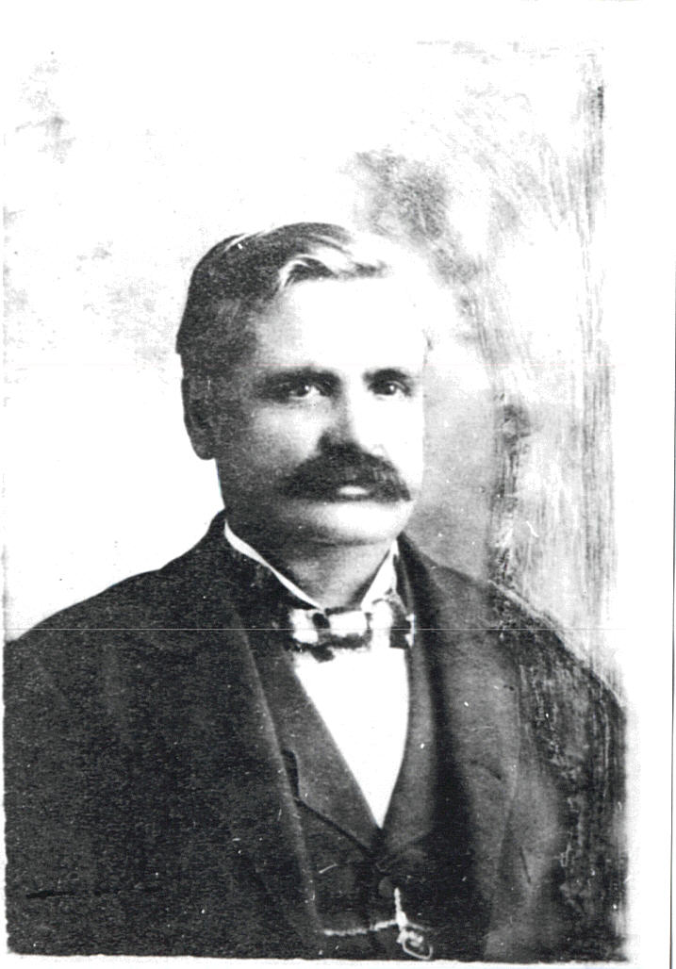

Lucretia Gaylord Edwards

1822 - 1886

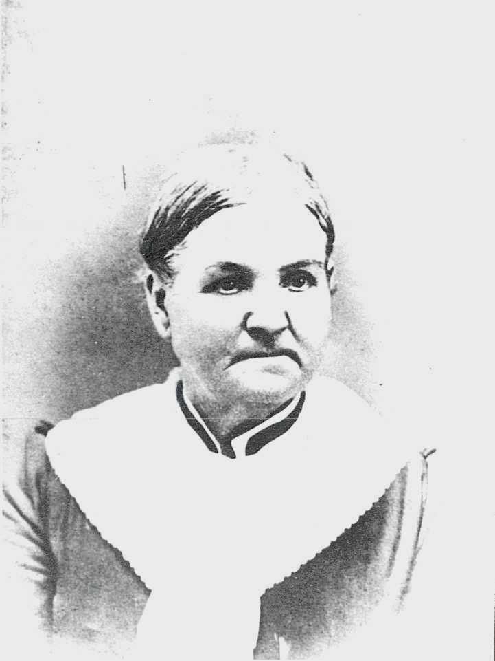

Francis’ brother, Thomas S. Edwards, Jr., also moved to a farm 6 miles west of Knoxville. Thomas, Jr. was widowed and remarried twice. According to his obituary, he was addicted to drinking alcohol, but later rid himself of the habit and became a teetotaler and a leader in the temperance movement. He affiliated with the Methodist Church (see Thomas S. Edwards obituary). He died in 1894 at the age of 70 of a carbuncle on his neck. He had two sons and three daughters. One son, William, suffered from a serious spinal injury received in a train accident on the way to the 1885 Iowa State Fair. He suffered a mental breakdown and spent the rest of his life at the state hospital in Mount Pleasant (see William Edwards obituary). Another son was also named Francis Marion Edwards (Frank). He became a veterinarian near Shannon City, Iowa. In July 1916 he was treating a horse that threw him against a manger and caused damage to this heart, lungs, and kidneys and eventually resulted in his death (see obituary for Dr. F.M. Edwards). He was married to Delia Shook, and they had six children.

Ellen Edwards and her husband Austin Henry Loveland also left Bureau County, IL, in 1857, and moved to Tama, Iowa. She died in Marshalltown.

**William Holiday Edwards (1847 – 1928)**

The second of Francis Marion and Lucretia Edwards’ children, **William Holiday Edwards**, was born in 1847 in Bureau County. In 1869 he married **Elizabeth Gibson,** daughter of **William** and **Mary Ann Ross Gibson**. William Gibson’s family left Tyrone County, Ireland, in 1836, lived in Canada one year, then moved to Ottawa, Illinois, until 1848. He then moved west to Sheffield, where he purchased land that had belonged to the Ross family in Concord Township, 3 miles northeast of Sheffield. William Gibson married Mary Ann Ross in 1849. She was born in New York in 1822, but her family was among the early settlers in Bureau County (see William Gibson obituary).

William Holiday and Elizabeth Gibson Edwards followed their parents to Iowa soon after they were married, in the fall of 1869. They settled on a farm near Knoxville, and the next year their first child, (**Asa) Gaylord Edwards**, was born. They had five other children. In 1874 they moved to the community of Kasson, in southern Madison County near the town of Lorimor, where two of his brothers already lived. Twenty years later they moved again, this time to a farm just two miles south of Winterset, near the present Winterset high school. William Edwards was known as “Democrat Bill,” and in his later years liked to pass his time discussing politics on the main square in Winterset. He died in 1928, and his wife passed away in 1929. They were the parents of seven children: Gaylord, Marion, Earl, Lura, Fred, Jay and Linnie. Fred was an invalid and appears in a family picture in a wheel chair.

William Holiday Edwards (1847-1928) and Elizabeth Gibson Edwards (1851-1929) family

Back row: Lura, Gaylord, Fred, Earl, Marion

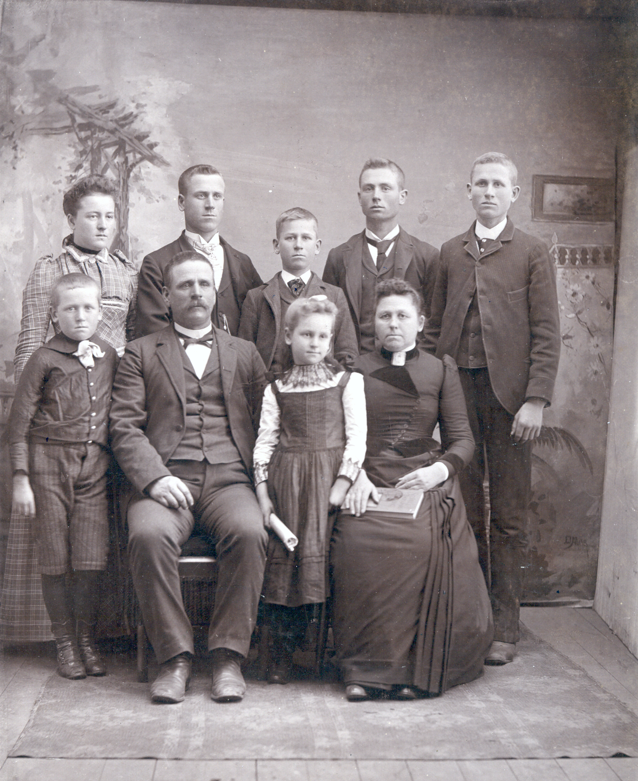

Front row: Jay, William H., Linnie, Elizabeth

**Gaylord Edwards (1870 – 1955)**

As a young man Gaylord Edwards returned to the community of Sheffield, Illinois, to help his mother’s sisters on their farm. It was there that he met **Anna Maude Heaton**, daughter of Cyrus and Isabella James Heaton. The Heaton and James families both arrived in Philadelphia in the 1600’s and eventually settled in Bureau County, Illinois (see Heaton and James/Evans family histories). Gaylord and Maude Heaton were married in 1901 and lived on a farm near Sheffield, where their first children, Florence and Marian, were born. After a few years they moved to Roulette, North Dakota to homestead. In 1909 they left North Dakota and joined Gaylord’s parents near Winterset, Iowa. They purchased a 160-acre farm six miles southeast of Winterset, in the center of Scott Township, from John Holmes, who had lived there for 55 years. The rest of their children, William, Irvin and Eleanor were born there.

Gaylord and Maude Edwards raised their five children on this farm. In 1934 they retired and moved to Winterset. Gaylord suffered from diabetes, and passed away in 1955. Maude continued to live in Winterset before spending the last years of her life in Marshalltown, Iowa, near her daughter Marian Miller and husband George. Their son William H. (Bill) Edwards and wife Kay Hanson lived on the farm until 1936, after which it was rented to Ralph and Mary Ham. Mary Graves Ham was a first cousin to Zella Graves Edwards. Irvin and Zella Edwards returned to the family farm in 1945 and lived there until 2001. The farm has been operated since 1973 by Byrle Algoe, grandson of Ralph and Mary Ham.

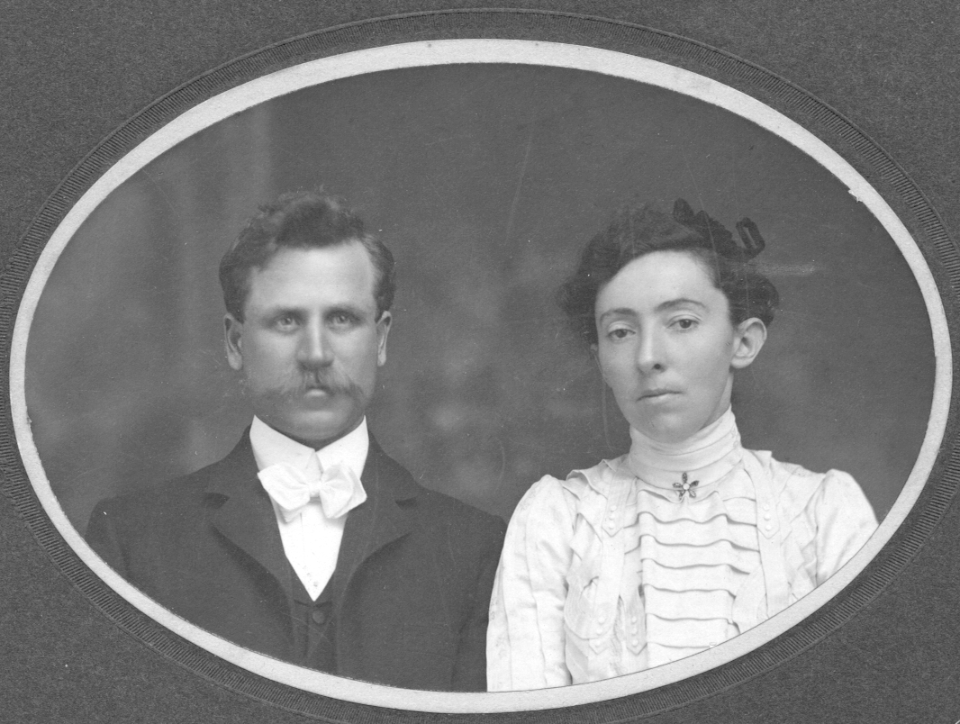

Gaylord and Maude Heaton Edwards

**Irvin Fredrick Edwards (1911- 2001)**

Irvin F. Edwards was the fourth child of Gaylord and Maude. He was born on the home farm in Scott Township, Madison County, Iowa, in 1911. He was christened Fredrick Irvin, but later reversed the order of his given names. After graduating from Winterset High School and Iowa State College, he worked for the Iowa Cooperative Extension Service as a 4-H agent in Scott County, IA. Later he obtained his master’s degree in animal science from Colorado State University. In 1940 he married **Zella Marian Graves**, who graduated in the same class from Winterset High School, and was also a graduate of Iowa State College. They made their home first in Urbana, Illinois, while Irvin obtained his Ph.D. degree. Later they lived one year in College Station, Texas, and four years in Logan, Utah. Irvin was a faculty member at Texas A. and M. University and Utah State University. In 1945 they returned to Winterset, Iowa, and settled on the Edwards home farm. Irvin engaged in farming until his retirement in 1973, while Zella’s career was as the librarian at Winterset High School. Irvin Edwards passed away on June 30, 2001. He lived on the Edwards farmstead southeast of Winterset until the last days of his life.

Irvin’s brother Bill was killed in an airplane crash in Texas while he was serving a mechanic in the U.S. Army in 1945. Marian Edwards married George Miller, and they made their home in Marshalltown, Iowa. Sister Florence married Dale Thomas and moved to Palo Alto, California, while Eleanor married Bill Stegeman. They have lived in California, Texas and Oregon.

Irvin and Zella were the parents of two sons, **Fredrick Irvin** (born in Utah) and William Marion (born in Des Moines). Fred married Linda Loftis of Craig, Nebraska, and they had one child, Timothy Neil, born in 1974. Tim Edwards married Natalie (Tasha) Hoggatt in Tekamah, Nebraska, in 1995. They had two children, Neil and Phoebe.

**William Marion Edwards** married **Jane Melissa Bowen** of Wooster, Ohio, in 1971. They met while participating in the International 4-H Youth Exchange program. Jane was a delegate to New Zealand, and William went to Mexico. After serving two years as Peace Corps volunteers in Colombia, they settled near Ames, Iowa. William is a professor of agricultural economics at Iowa State University and Jane is an international program advisor at ISU. They have two children, David (1975) and Sarah (1978).

Compiled by William M. Edwards, June 2003.

**John C. Gaylord History (1797 – 1878)**

John C. Gaylord was born in Luzerne County, Pennsylvania, in 1797, son of Chauncy Gaylord. He moved to Wayne County, New York, east of Rochester, and married Elizabeth Terry of the same community in 1820. They lived just a few miles from Palmyra, the site where in 1827 Joseph Smith received the visions that led him to establish the Church of Jesus Christ of Latter Day Saints (LDS), also known as the Mormon Church, in 1830. Over 1,000 members were added to the Church within a year. John Gaylord was an early member of the movement, as was his wife’s family. He was baptized into the Church in August 1835. Smith and his followers moved from New York to Kirtland, Ohio, northeast of Cleveland, in 1831, and John and Elizabeth Gaylord, with their 8-year old daughter, Lucretia, were part of the group.

John Gaylord was ordained an elder in 1836 and appointed to a leadership position (one of seven “Presidents of Seventies”) in the new church in April 1837, but was excommunicated in January 1838 along with many other elders for questioning Church authorities. The headquarters of the LDS Church was moved to Missouri soon after, but the group was unpopular there, and in 1839 they moved to Nauvoo, Illinois, on the banks of the Mississippi River. In a few years the community grew to over 10,000 people.

John Gaylord and his family followed them to Nauvoo, and he rejoined the LDS Church in August 1841. His name is also listed among Church members in Missouri prior to the move to Nauvoo. Elizabeth Gaylord is listed as passing away in 1839, at age 34, and is buried in Knox County, Illinois, not far from Nauvoo. John Gaylord remarried, to Elvira Edmunds, widow of William Edmunds, on Dec. 31, 1840 in Knox County, IL. He may have returned to Ohio, as his name appears in Church records there as late as October 1841.

After the death of Joseph Smith in 1844, the leadership of the Church was hotly contested for several years. James J. Strang, who was a recent convert to the faith, claimed to have a letter in which Joseph Smith had named him as his successor. John Gaylord was a supporter of Strang. He even was made an earl in the “Order of Illuminati,” a select group of Church leaders loyal to Strang. He was also president of the “Voree Stake,” a new Mormon community that was established by Strang 3 miles west of Burlington, in southeastern Wisconsin. When Brigham Young assumed leadership of the Church in 1846, however, it was decided that they would leave Nauvoo and start a new settlement in Utah.

John Gaylord chose not to follow Young to the West. The Wisconsin Mormons and several other LDS groups elected to stay in the Midwest. John Gaylord maintained his status in the Wisconsin community, and during the period 1855 to 1860 helped start the “Reorganized” LDS Church, which today is headquartered in Independence, Missouri. He was made a member of the high council in 1860. He also worked as a carpenter, and died in 1874 or 1878, near Burlington, Wisconsin. Elvira died in 1885 in Harrison County, Iowa.

